**Introduction :**

A client had layoff at his work location in Newyork and now has to move to Toronto from Marble Hill to join the new work location. He wants to live in the similar neighborhood (Neighborhood with similar venues in the vicinity) as he is used to in Marble Hill, NY. My challenge is to find a similar neighborhood for him to rent/buy a house so he can enjoy similar lifestyle in Toronto as he used to in Marble Hill, thus reducing the impact of the change this layoff has brought on him.

**Data :**

To get New York Neighborhood information below link was used

<https://cocl.us/new_york_dataset>

The data was loaded in a dataframe and from the data I obtained latitude and longitude of the clients original neighborhood Marble Hill, NY.

I will use the below Wikipedia page to get the Toronto Neighborhood details <https://en.wikipedia.org/wiki/List_of_postal_codes_of_Canada:_M>

**Methodology :**

1. **Understanding the neighborhood the client is used to**

* From the above NY dataset I got the latitude and longitude of the Marble Hill neighborhood.
* Using the FourSquare API, I got the venues and their categories in Marble Hill Neighborhood. And checked what are the most common venue categories near the Marble Hill area by getting 100 venues in 1 km radius.
* I then got top ten venue categories to get an idea on what kind of neighborhood the client is used to and looking for in Toronto
* Using the value_count exploratory analysis, I found the top 4 venue categories as Park, Mexican Restaurant, Supermarket, Pharmacy

1. With the Exploratory analysis done above, find similar neighborhood in Toronto

* I used the below Wikipedia page to get the Toronto Neighborhood details <https://en.wikipedia.org/wiki/List_of_postal_codes_of_Canada:_M>
* After scraping the neighborhood data for Toronto I populated it in pandas dataframe
* Then for each neighborhood in Toronto I got the 100 venues in 1 km radius and group them by venue category.
* Then removed all the categories that do not match with the top 4 categories.
* Removed all the neighborhood that do not have any of the top 4 categories

**Results :**

From the analysis done below neighborhoods in Toronto were found matching the Marble Hill neighborhood (highlighted)

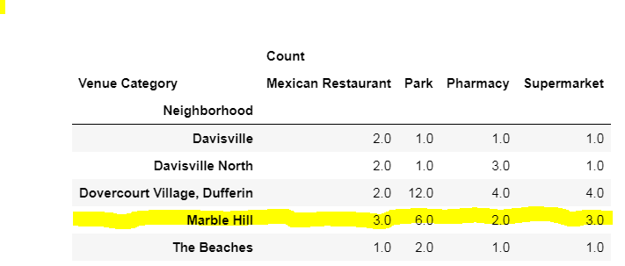

**Discussion :**

Based on the results above the client may choose to rent/buy in any of the below neighborhoods. With the most favorable being Dovercourt Village, Duffering neighborhood.

Davisville

Davisville North

Dovercourt Village, Dufferin

The Beaches

**Conclusion :**

With the anlysis above I was able to provide a neighborhood similar to Marble Hill neighborhood. The analysis can be expanded to look at the rent/house prices or the schools in the neighborhood.